**Module – 3**

**Problem 1:** Perform all the arithmetic operations (Addition, Subtraction, Multiplication, Division, Exponent, Modulus, Integer Division) on the given vectors:

a = c(8.2, 3, 6, 1.4), b = c(2, 4, 8, 6)

**Ans:-**

a <- c(8.2, 3, 6, 1.4)

b <- c(2, 4, 8, 6)

length(a) >>> 4

length(b) >>> 4

print(a+b) >>> 10.2 7.0 14.0 7.4 #Addition

print(a-b) >>> 6.2 -1.0 -2.0 -4.6 #suntraction

print(a*b) >>> 16.4 12.0 48.0 8.4 #Multiplication

print(a/b) >>> 4.100 0.750 0.750 0.233 #Division

print(a^b) >>> 6.724000e+01 8.100000e+01 1.679616e+06 7.529536e+00 #exponent

print(a%%b) >>> 0.2 3.0 6.0 1.4 #Modulas

print(a%/%b) >>> 4 0 0 0 #Integer division

**Problem 2:** Prove associative law (which means that rearranging the parentheses in an expression will not change the result) for addition and multiplication using the given vectors. Find the LHS (Left Hand side) and RHS (Right Hand Side) and then compare both using relational operators to prove the law.

a = c(8.2, 3, 6, 1.4), b = c(2, 4, 8, 6), c = c(1, 2.2, 2.6, 5)

**Ans:-**

a <- c(8.2, 3, 6, 1.4)

b <- c(2, 4, 8, 6)

c <- c(1, 2.2, 2.6, 5)

length(a) >>> 4

length(b) >>> 4

length(c) >>> 4

#Associative law for Addition

# a+(b+c) = (a+b)+c

lhs <- a+(b+c)

print(lhs) >>> 11.2 9.2 16.6 12.4

rhs <- (a+b)+c

print(rhs) >>> 11.2 9.2 16.6 12.4

#comparing LHS with RHS using relational operators

print(lhs==rhs) >>> TRUE TRUE TRUE TRUE

print(lhs!=rhs) >>> FALSE FALSE FALSE FALSE

#Associative law for multiplication

# a*(b*c) = (a*b)*c

lhs2 <- a*(b*c)

print(lhs2) >>> 16.4 26.4 124.8 42.0

rhs2 <- (a*b)*c

print(rhs2) >>> 16.4 26.4 124.8 42.0

#comparing LHS with RHS using relational operators

print(lhs2==rhs2) >>> TRUE TRUE TRUE FALSE

print(lhs2!=rhs2) >>> FALSE FALSE FALSE TRUE

**Problem 3:** Create a 2x4 matrix and find the result of multiplication of the matrix with its transpose using an appropriate in-built method.

**Ans:-**

a <- matrix(2:9, nrow = 2, ncol = 4, byrow = T)

a

View(a)

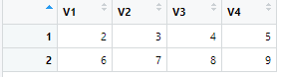

b <- matrix(2:9, nrow = 4, ncol = 2, byrow = F)

b

View(b)

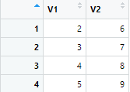

c <- a%*%b

c

View(c)

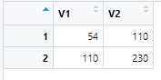

**Problem 4:** Convert the given vector into a data frame using an appropriate function then convert the same into a matrix.

**a<- c(1,2,3) ; b<- (10,20,30) ; c<- (100,200,300); d <- (1000,2000,3000)**

**Ans:-**

a<- c(1,2,3)

b<- c(10,20,30)

e<- c(100,200,300)

d <- c(1000,2000,3000)

#Converting vector into Data frame

df <- data.frame(a,b,e,d)

df

View(df)

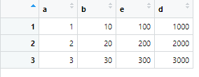

#converting vector to matrix

mat_1 <- matrix(c(a,b,e,d),nrow = 3, ncol = 4,byrow = F)

mat_1

View(mat_1)

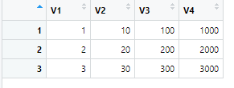

**Problem 5:** Given is the information of creating a data frame. What would be the resultant of doing “C.df%*%B”

> C.df <- data.frame(a,b,c,d)

> C.df

a b c d

1 1 10 100 1000

2 2 20 200 2000

3 3 30 300 3000

> ‘Given is the output of B:’

B

[,1] [,2] [,3]

a 1 2 3

b 10 20 30

c 100 200 300

**Ans:-**

a <- c(1,2,3)

b <- c(10,20,30)

c <- c(100,200,300)

d <- c(1000,2000,3000)

C.df <- data.frame(a,b,c,d)

C.df

View(C.df)

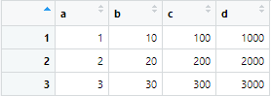

B <- matrix(c(a,b,c),nrow = 3,ncol = 3,byrow = T,

dimnames = list(c('a','b','c'),c('1','2','3')))

B

View(B)

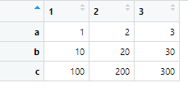

Resultant is

r <- C.df%/%B

r

a b c d

1 1 5 33 1000

2 0 1 6 200

3 0 0 1 30

View(r)

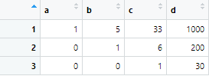

**Note:** Use R to solve the given problems in the above. After you do so, cut and paste your input and output from R to Word, else you can submit your code file along with the question and the question number. If you are sending it in a word file add numbering in Word to identify each part of each problem. (Do this for every problem from now on.)